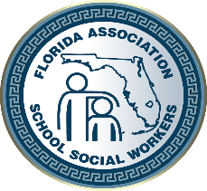

FLORIDA ASSOCIATION OF
SCHOOL SOCIAL WORKERS
Ruth Anne St. John Scholarship

Eligibility:
- Applicant must currently be enrolled in a Masters of Social Work program at an Accredited Florida College or University
- Applicant must have accrued at least thirty semester hours toward the MSW Degree by the time the application is submitted, or is an Advanced Standing (post BSW) student.
- Applicant must demonstrate financial need.
- Preference will be given to student members of FASSW.

Application must be emailed by September 30, 2022

Submit e-application and other required items to:

Karie M. Johnston, MSW, LCSW
FASSW Immediate Past President
At Karie.Johnston@ocps.net

The selected candidate will be announced during the Conference.

Applicants must submit the following for a complete application packet by deadline date:
  - Florida Association of School Social Worker’s Scholarship Application
  - Evidence of approval in a School Social Work Placement
  - Reason for seeking scholarship (limit to a one-page letter)
  - Ad Vita and brief statement about future plans in School Social Work
  - An unofficial current college transcript (The selected candidate MUST provide an
official college transcript once notified)
  - Two to five letters of reference (at least one from a graduate school faculty member and one from a field placement supervisor or instructor)
* These letters must include reference contact email and phone number for verification

The scholarship will be presented to the recipient at the 75th FASSW Conference, “Helping Students and Families Shine Brighter for 75 Years”, on Friday, October 8th, to be held this year at:

Hilton Tampa Airport Westshore, 2225 North Lois Avenue Tampa, 33607

