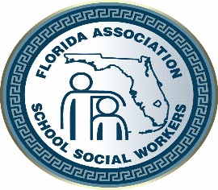
2019 FASSW CONFERENCE
REQUEST FOR WORKSHOP
PRESENTER PROPOSAL FORM

The Florida Association of School Social Workers (FASSW) Conference Program Committee is now accepting workshop proposals for presentations at the 73rd Annual FASSW State Conference hosted by Broward County School Social Workers. The conference will be held at the Embassy Suites in Fort Lauderdale, Florida October 16-18, 2016. The 2019 conference theme is:

MENTAL HEALTH STRATEGIES FOR STUDENT ENGAGEMENT AND ACADEMIC SUCCESS
We invite school and community social workers and mental health professionals and organizations in related fields to submit a workshop proposal for participation consideration.
Deadline to submit is August 30, 2019!

Presentation Title

Please select availability for presentation:
Wednesday, October 16th ☐ a.m. ☐ p.m. ☐ both
Thursday, October 17th ☐ a.m. ☐ p.m. ☐ both

Presenter Information:
Complete all information for each presenter in the order you want it to appear in the program listing. Use separate sheets as needed, typewritten information only. Attach a brief bio‐sketch for each presenter, including experience and qualifications, not to exceed 25 words. If selected, the information provided will appear in the conference booklet as submitted on this form and attachments. Please include presenters’ names on all attachments.

Presenter’s Name: |  |  |  | Credentials:
Job Title: |  |  |  | Employer:
Preferred Mailing Address:
Contact Number: |  |  |  | Contact E-mail:

Please email form to fasswconferencechair@gmail.com

Note conditions/liabilities indicated below:
We regret to inform you that presenters will not receive any compensation for their presentation unless otherwise arranged in writing. Hotel, travel and other expenses, such as handouts are the sole responsibility of the presenters. Presenters are required to register for the State Conference if they wish to attend other activities. The program conference committee reserves the right to change the length and format of the presentation after notification has been provided. Only the first named presenter will be notified in September, 2019 of acceptance. Your presentation may be selected for consideration as a CEU workshop. Submission of Request for Speaker Proposal Form acknowledges acceptance of these conditions and limitations.
2019 FASSW Conference
MENTAL HEALTH STRATEGIES FOR STUDENT ENGAGEMENT AND ACADEMIC SUCCESS
Presenter Proposal Information
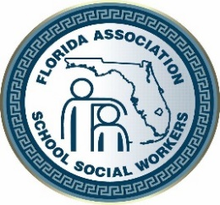
Presenter(s)
Presenter’s Name:
Organization:
Position/Title:
Co-Presenter’s Name:
Organization:
Position Title:
Presentation Format
General Topic:
Content Focus Area:
 | Academic Engagement |  |  |  |  |  |  |  |  |  | Attendance |  |  |  |  |  | Behavior Modification |  |  |  |  |  |  | Mental Health
Presentation Style:
 | Lecture |  | Lecture plus Interactive Activities |  |  |  |  |  |  |  |  |  |  |  | Out of Seat Activities |  |  |  |  |  |  | Panel Discussion |  |  |  | Other
Target Audience: |  |  |  |  |  |  |  | Elementary |  |  |  |  | Middle |  |  |  |  |  | High
Skill Level: |  |  |  |  | Introductory |  |  |  |  |  |  |  | Intermediate |  |  |  |  |  | Advance

Audio/Visual Needs
Please check the audio/visual items needed for this presentation:
 | Laptop |  | Projector |  |  | Extension Cord |  | Other:
Please check the audio/visual items you will be able to provide for your presentation:
 | Laptop |  | Projector |  |  | Extension Cord |  | Other:
Learning Outcome/Objectives:
Objective #1:
Objective #2:
Objective # 3:

Abstract
Please type a brief abstract of your presentation in 75 typed words or less
Presentation Title:
Presenter(s):

FASSWConferenceChair@gmail.com

