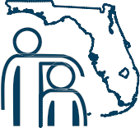

The 73rd Annual Conference
S
of The Florida Association
of School Social Workers
I

MENTAL HEALTH STRATEGIES FOR STUDENT ENGAGEMENT AND ACADEMIC SUCCESS
for All Mental Health Professionals

Early Bird
Registration
Now Open!

Wednesday, October 16 to
Friday, October 18, 2019

The Embassy Suites Hotel
1100 S.E. 17th Street
Fort Lauderdale

Attend innovative workshops, network with colleagues, add to your practice toolkit, and earn free CEUs for LCSW, LMHC & LMFT.

Stay updated by visiting the website at FASSW.org

